Department of Botany
Integrated Pest Management 2021-22
Integrated peste management is a very informative practice at the point of view for the farmers and student because farmers are not educated so as understand the name of the pesticides herbicides which are very basic for the farmers therefore when student ,farmer,parent and faculty of our college working to solve these problems.Our hounerable principal taking initiative for these activity and deliver and organise a lecture for the farmers and parents of our college student on Our faculty member Prof.Pathade K.B taking information from different NGO and Agri related retailers and wholesalers. Our college students are trained to identify the peste on the crop and how to control that pest in different ways. In our practice we made a survey of Some villleges of Shrigonda tehsil
1.Adhalgaon,Autewadi,Padhegaon,Kasti,Nimpangaon,Dandekar Mala,Hiradgaon,Takli kade ,Shendgewadi,Ghaypatwadi etc.
In all that colleges we have surveyed firstly which crops have been taken by farmers in there field After survey we have concluded that 1.Dalimb 2.Limbu 3.Chiku 4.Grapes 5.Guava that five most fruit yielding and economically important plant have grown by the farmers.
After that we surveyed crop yielding plants.then we concluded that these regions can grow Udid,Mug,Soyabben,Tur Onion,Tomato,Brinjal Bhendi,Palak,Cabbage, Sugarcane And some flower yielding crop like Gulab and Zendu that is seasonal crop but it is economically important. And finally surveyed about which crop is attacked by different pests and find the solution to control that pest. There are some names of the pest that are commonly attack on crops is mili bug

Adhalgaon
Sr.No. | Crop | Brand Name | Technical Name
1 | Sugarcane | Hamla 550 | Chloropyriphiost cypermenthon
 |  | Lesenta | Indiocloropid + Phyprolinid
 |  | Coragen | Chloranthilinepryole
 |  | Regence | fipronil
 |  | Proclaim | Ememectin benzoate
 |  | Actra | Thimethazon
2 | Maize | Neem gold | Neem oil 1000ppm
 |  | Marshal | Carbadosulphan
 |  | Confidor | Imidacloprid
 |  | Tata Manik | Acetemaprid
3 | Cotton | Prafex | Profenofost + cypermothix
 |  | Decis 100 | Deltamethane
4. | Onion | Confider | Imidacloprid
 |  | Karate | Lamda cyralothrin
 |  | Tafgor | Dimethatesoyfor
 |  | Tatamida | Imidacloprid
5 | Soyabeen | Regent | fipronil
 |  | Marshal | Carbasulfan
 |  | Hamla 550 | Chloropyriphos cyperimethon
 |  | Asotaf | Acephote
 |  | Takumi | Flumediamide (bereria)
6 | Tomato | Tatamanik | Acetamoprid
 |  | Volian flexi | Chlorantranil proletthmaytaxon
 |  | Biosor | Laminaria plantedract
 |  | Monocil | Monochlorophos

Padhegaon
Sr.No. | Crop | Brand Name | Pesticide
1 | Sugarcane | Coragen brand spectrum | FMC Dupont
 |  |  | Cyprogold
 |  | Syngenta Karate
 |  | Profex Super
 |  | Confidor
2 | Cotton | Cotton Ballworm | 19:19:19 NPK
 |  |  | A to Z Phosphate solubelizing fungal
 |  | Tafgor
 |  | Agrowet
3 | Wheat | Confidor insecticide
 |  | Tata Tufgor | Dimethoate
 |  | Syngenta Insect pegasys 25gm
 |  | Delegate
4 | Maize |  | Dimethoate
 |  |  | Trichograma chilonis
 |  |  | Kryaosopha Karnia
5 | Soyabeen | Syngenta alika | Thiamethaxon
 |  | Syngenta ampligo | Chlorothinoprex
 |  |  | Beauveria Bassiana

Dandekar Mala
Sr.No. | Crop | Brand Name | Pesticide
1 | Watermelon |  | Bio-303 Daman-P-47
 |  |  | Coragen Proclaim ,contact Sulphur
2 | Grapes |  | Copper sulphate(bordo) Tracer Domark ,Actra,Ulala Visma,Solomon Confidor Amisor top
3 | Onion |  | Cabrio Top Rogor Hara Saaf,Antracal Deritol
4 | Pomogranate |  | Bactoraze,Thrips raze, Curzate,Kocide, Blue copper Fantic _M.
5 | Brinjal |  | Profex,Super Tracer,Marvel Plus,Proclaim Soloaen M-45.
6 | Tomato |  | Actra,Bavistin Polyram,

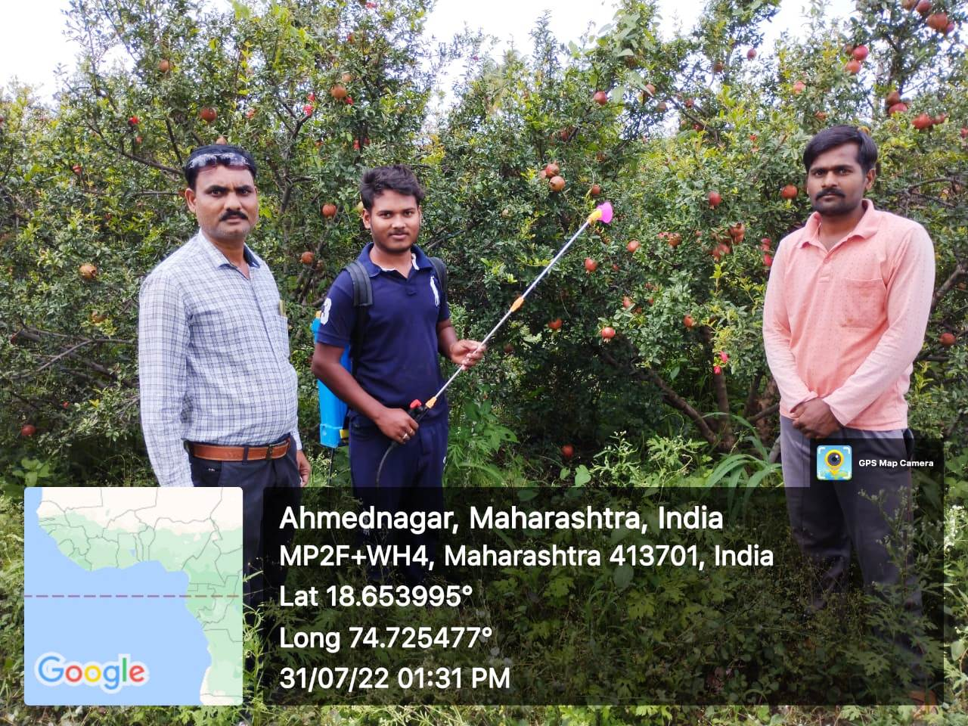
Spraying pesticide on pomegranate
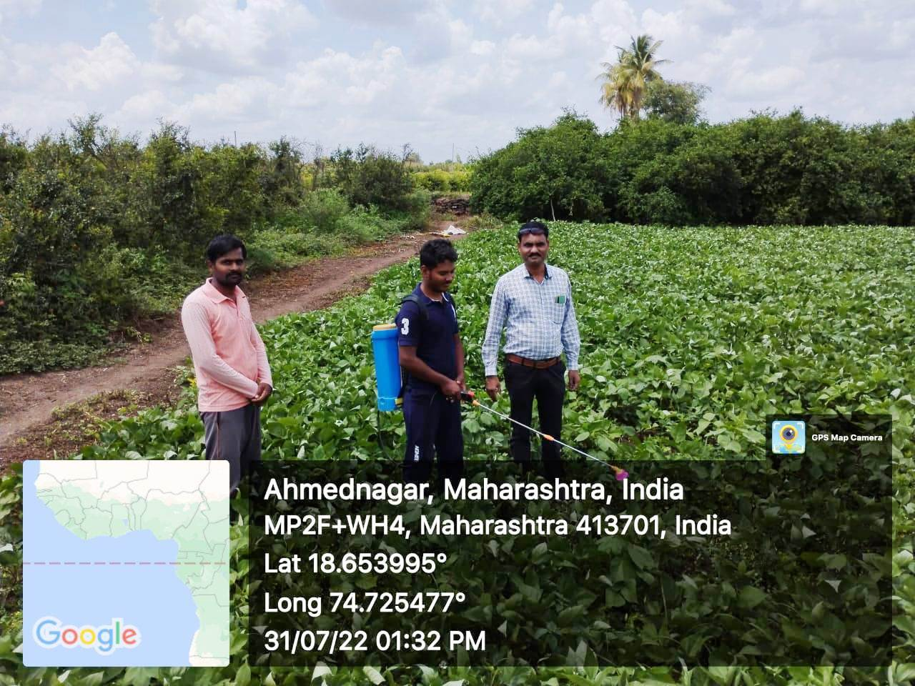
Spraying pesticides on Udid farm

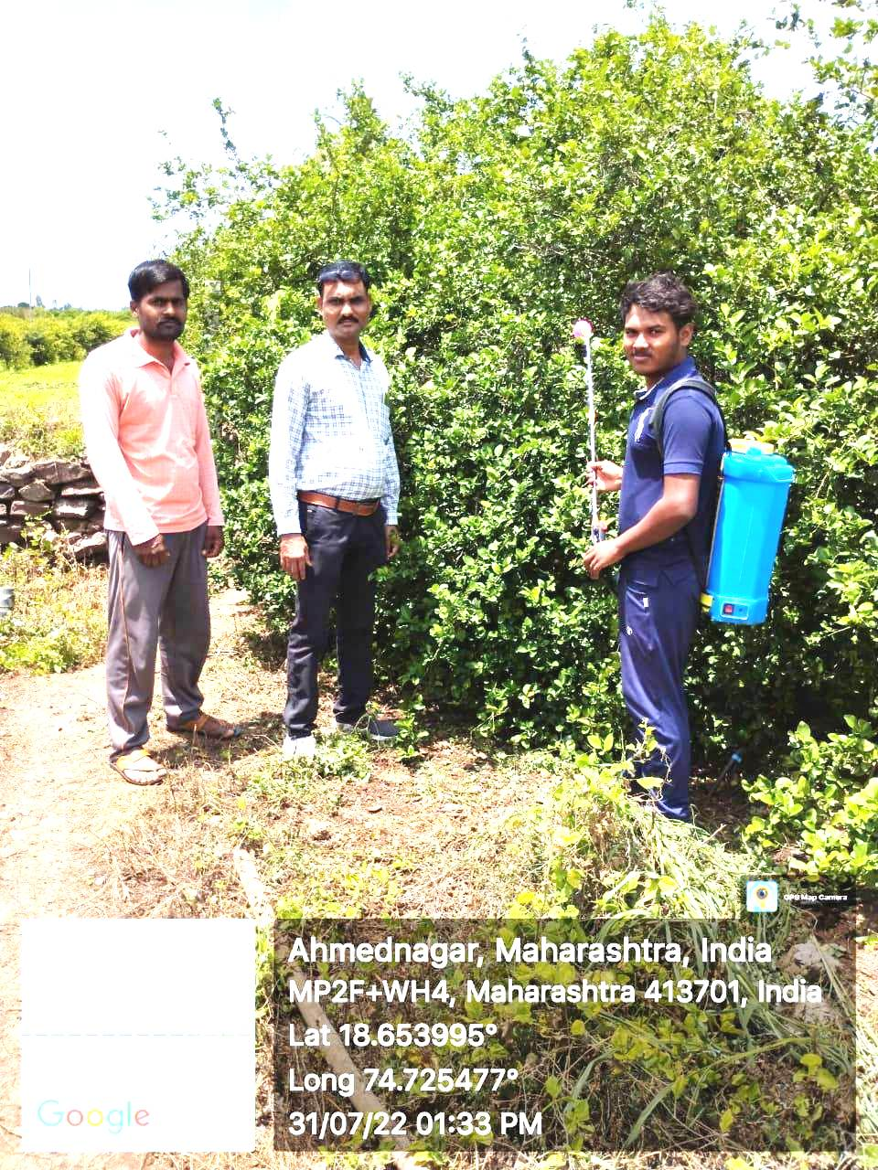

Spraying pesticides on lemon farm

